Enforce least-privilege access through identity-aware, application-specific access policies using Zscaler Private Access (ZPA).

List of teammates

S.no | Name | Collage | Contact
1. | ADITHYAN .S | Bishop Appasamy college of arts science | sadithyan368@gmail.com
2. | ABISHEK .A | Bishop Appasamy college of arts science | Abishek.ingo@gmail.com
3. | MESHACH FERNANDEZ .M | Bishop Appasamy college of arts science | meshahfernandez34@gmail.com
4. | MANAVALAN .M | Bishop Appasamy college of arts science | mmanavalan564@gmail.com
5. | SYED HAFNAS .A | Bishop Appasamy college of arts science | 27syedhafnash@gmail.com

INTRODUCTION:
In an era where the digital landscape is constantly evolving, organizations face an ever-increasing threat from cyberattacks. The need for swift and effective incident response has become paramount to safeguard sensitive data, protect digital assets, and maintain the trust of stakeholders. In response to this growing challenge, we present a visionary project: the development of an AI-driven incident response platform that empowers cybersecurity teams with the tools to automate and enhance incident triage and response tasks.

In response to the evolving threat landscape and the dissolution of the traditional network perimeter, modern enterprises are rapidly shifting away from legacy VPN-centric remote access models. These conventional approaches often grant excessive network-level access, creating a significant attack surface and increasing the risk of lateral threat movement. To address these challenges, this project centers on the implementation of a Zero Trust security architecture, fundamentally operating on the principle of "never trust, always verify." By moving beyond location-based access, we aim to establish a security posture where trust is no longer implicit, and access is determined by granular context rather than network connectivity.

The core of this initiative involves the deployment of Zscaler Private Access (ZPA), a cloud-delivered Zero Trust Access solution designed to create identity-aware, application-specific connectivity. Unlike traditional VPNs that place users on the internal network, ZPA leverages a "service-initiated" model to establish direct, one-to-one connections between authorized users and specific applications, completely hiding the corporate network and IP address space from the internet. This ensures that users connect exclusively to the applications they are permitted to access, based on continuous identity verification and context, rendering the applications invisible to unauthorized users and preventing common attack vectors such as port scanning and distributed denial-of-service attacks.

Ultimately, this project will enforce a least-privilege access model, ensuring users and devices are granted the minimum required access necessary to perform their functions. By decoupling application access from network access, we will eliminate the risk of lateral movement across the network, as users have no visibility or connectivity to other hosts. This strategic move not only significantly enhances security by reducing the attack surface but also simplifies the user experience and reduces operational overhead associated with legacy remote access infrastructure, positioning the organization at the forefront of secure and efficient access management.

ABSTRACT:
The proliferation of hybrid work and cloud-based resources has rendered traditional perimeter-based security models, such as VPNs, obsolete and increasingly dangerous. These legacy solutions often provide overly broad network access, exposing organizations to significant risks including lateral threat movement and an expanded attack surface. This project addresses these vulnerabilities by implementing a Zero Trust Architecture (ZTA) utilizing Zscaler Private Access (ZPA). The primary objective is to transition from network-centric to identity-centric access, thereby enforcing the principle of least privilege.

The methodology involves deploying ZPA’s cloud-based service to create application-specific, identityaware micro-tunnels. Unlike conventional VPNs that place users on the internal network, this solution establishes direct, one-to-one connections between verified users and authorized applications. The network infrastructure and all non-authorized applications remain completely invisible to the end-user, effectively eliminating surface for reconnaissance and attack. Access policies are dynamically governed by user identity, device posture, and contextual attributes, ensuring that connectivity is strictly limited to what is explicitly required for specific job functions.

The implementation of ZPA successfully decouples application access from network access, resulting in a demonstrable reduction in the organization's attack surface and the complete prevention of lateral movement. This project delivers a robust, scalable, and user-friendly remote access framework that aligns with modern security best practices. By shifting to an identity-aware, least-privilege model, the organization significantly enhances its security posture while simultaneously reducing operational complexity and improving the end-user experience.
Use Case Scenarios

Scenario 1: Finance Department Access to ERP System
A senior accountant in the finance department needs to access the corporate Enterprise Resource Planning (ERP) system to process monthly payroll. The user connects from a remote location using their company-managed laptop. Upon launching the ZPA Client Connector, they authenticate via Azure Active Directory with multi-factor authentication (MFA). ZPA evaluates the user's identity, group membership (Finance_ERP_Users), device posture (antivirus active, disk encryption enabled), and connection context. The policy engine determines that the user is authorized and brokers a secure, direct micro-tunnel to the ERP application only. The user can interact with the ERP interface, but has no visibility or network-level access to any other internal systems, such as development servers or the HR database.
Output:
• User authenticated and authorized based on identity and group membership
• Direct micro-tunnel established specifically to the ERP application
• All other internal applications and network segments remain invisible and inaccessible

Scenario 2: Contractor Access to Specific Project Repository
An external software consultant is hired for a three-month project and requires access only to a specific Git repository hosted on an internal server. The contractor is onboarded as a guest user in the identity provider and assigned to the "Project_X_Contractors" group. When the contractor connects using the ZPA client, the system verifies their identity and checks the device for basic security compliance (OS patch level, firewall enabled). ZPA enforces a policy that grants access exclusively to the Git repository application (port 22/SSH or port 443/HTTPS) during business hours (9 AM to 5 PM). The contractor can clone, push, and pull code, but cannot discover or connect to any other internal resources, including the corporate intranet or file servers.
Output:
• Time-bound and role-specific access enforced
• Contractor restricted to a single application (Git repository)
• Lateral movement to adjacent systems completely blocked

Scenario 3: Executive Access to Confidential Board Documents
A company executive needs to access a confidential folder containing board meeting materials hosted on an internal file server. The executive connects from a tablet device while traveling internationally. ZPA integrates with the mobile device management (MDM) solution to verify that the tablet is compliant (not jailbroken, passcode enabled, encryption active). Upon successful authentication, ZPA evaluates the policy: "If user is in 'Executive_Board' group AND device is MDM-compliant AND connection is from a trusted country (allowlist), THEN grant access to 'Board_Documents' application." The executive is connected directly to the specific file share, and all data in transit is encrypted via TLS. Any attempt to access other shares or network resources is automatically blocked and logged.
Output:
• Context-aware access based on user role, device posture, and geographic location
• Granular access to a specific file share (Board_Documents)
• Comprehensive logging of access events for audit and compliance

Stage 1

Title of the project :
Enforce least-privilege access through identity-aware, application-specific access policies using Zscaler Private Access

Overview:
In response to the evolving threat landscape and the dissolution of the traditional network perimeter, modern enterprises are rapidly shifting away from legacy VPN-centric remote access models. These conventional approaches often grant excessive network-level access, creating a significant attack surface and increasing the risk of lateral threat movement. To address these challenges, this project centers on the implementation of a Zero Trust security architecture, fundamentally operating on the principle of "never trust, always verify." By moving beyond location-based access, we aim to establish a security posture where trust is no longer implicit, and access is determined by granular context rather than network connectivity. The core of this initiative involves the deployment of Zscaler Private Access (ZPA), a cloud-delivered Zero Trust Access solution designed to create identity-aware, application-specific connectivity. Unlike traditional VPNs that place users on the internal network, ZPA leverages a "service-initiated" model to establish direct, one-to-one connections between authorized users and specific applications, completely hiding the corporate network and IP address space from the internet. This ensures that users connect exclusively to the applications they are permitted to access, based on continuous identity verification and context, rendering the applications invisible to unauthorized users and preventing common attack vectors such as port scanning and distributed denial-of-service (DDoS) attacks. Ultimately, this project will enforce a least-privilege access model, ensuring users and devices are granted the minimum required access necessary to perform their functions. By decoupling application access from network access, we will eliminate the risk of lateral movement across the network, as users have no visibility or connectivity to other hosts. This strategic move not only significantly enhances security by reducing the attack surface but also simplifies the user experience and reduces operational overhead associated with legacy remote access infrastructure, positioning the organization at the forefront of secure and efficient access management.

List of teammates

S.no | Name | Collage | Contact
1. | ADITHYAN .S | Bishop Appasamy college of arts science | sadithyan368@gmail.com
2. | ABISHEK .A | Bishop Appasamy college of arts science | Abishek.ingo@gmail.com
3. | MESHACH FERNANDEZ .M | Bishop Appasamy college of arts science | meshahfernandez34@gmail.com
4. | MANAVALAN .M | Bishop Appasamy college of arts science | mmanavalan564@gmail.com
5. | SYED HAFNAS .A | Bishop Appasamy college of arts science | 27syedhafnash@gmail.com

List of Vulnerability Table

S.no | Category name | Vulnerability Name | CWE/CVE - No
1. | Broken Access Control | Relative Path Traversal | CWE-23
2. | Security Misconfiguration | Configuration | CWE-16
3. | Software Supply Chain Failures | Unimplemented or Unsupported Feature in UI | CWE-447
4. | Cryptographic Failures | Weak Encoding for Password | CWE-261
5. | Injection | Improper Input Validation | CWE-20
6. | Insecure Design | Permissive List of Allowed Inputs | CWE-183
7. | Authentication Failures | Improper Authentication | CWE-287
8. | Software or Data Integrity Failures | Untrusted Search Path | CWE-426
9. | Security Logging & Alerting Failures | Information Loss or Omission | CWE-221
10. | Mishandling of Exceptional Conditions | NULL Pointer Dereference | CWE-476

REPORT:-
1.
Vulnerability Name:- Relative Path Traversal
CWE/CVE : -CWE-23
OWASP/SANS Category:-A01:2025 Broken Access Control
Description:-
Relative Path Traversal is a security vulnerability that occurs when an application allows users to access files and directories outside the intended directory structure by manipulating file path inputs. This vulnerability arises when a program does not properly validate or sanitize user-supplied file paths, enabling attackers to traverse through the system’s directory structure and access restricted files.
Relative path traversal is commonly seen in web applications where file names or paths are taken from user input. Attackers exploit this vulnerability by inserting special directory navigation characters such as ../ into file paths. These characters instruct the system to move up one directory level, allowing attackers to access files located outside the permitted directory.
This vulnerability is documented in the **Common Weakness Enumeration as **CWE-23 and is often referred to as directory traversal.

Business Impact::-

1. Exposure of Sensitive Business Data
One of the most serious impacts is the unauthorized access to confidential files. Attackers may retrieve important business data such as:
- Customer information
- Financial records
- Internal documents
- Configuration files
- Source code
If this data is leaked, it can damage the organization's trust with customers and partners.

2. Financial Loss
Data breaches resulting from path traversal vulnerabilities can lead to significant financial losses. Organizations may face costs related to:
- Incident response and forensic investigations
- System recovery and remediation
- Legal fees and regulatory penalties
- Customer compensation
In some industries, data protection regulations require organizations to pay large fines when sensitive information is exposed.
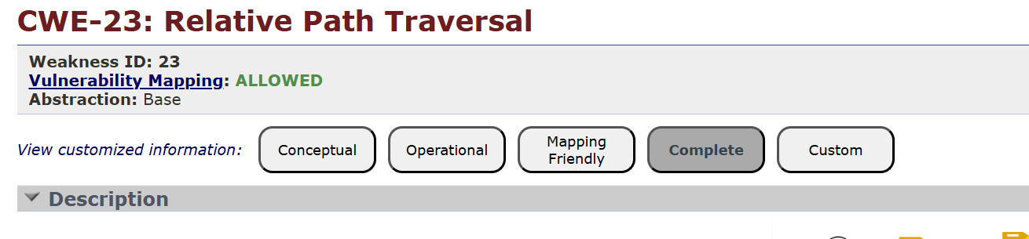

2.
Vulnerability Name:- Configuration
CWE/CVE :-CWE-16
OWASP/SANS Category:-A02:2025 Security Misconfiguration
Description:-
A Configuration Vulnerability occurs when a system, application, or network is improperly configured, leading to potential security weaknesses that attackers can exploit. Configuration settings determine how software, servers, databases, and security mechanisms operate. If these settings are not correctly defined or maintained, they may expose sensitive information, allow unauthorized access, or weaken system defenses.
Many configuration vulnerabilities arise because systems are deployed with default settings, unnecessary services, or weak security controls. During installation, software often includes default configurations designed for ease of setup rather than strong security. If administrators fail to modify these settings, attackers may exploit them to compromise the system.
Configuration vulnerabilities are widely recognized in cybersecurity frameworks such as the **OWASP security guidelines, particularly under the category **Security Misconfiguration. These vulnerabilities are among the most common causes of data breaches and system compromises.

Business Impact::-

1. Data Breaches and Information Exposure
Improper configuration can expose sensitive data such as:
- Customer personal information
- Financial records
- Business documents
- System configuration files
If attackers gain access to these resources due to weak configuration settings, it can result in data breaches, which may damage the organization’s credibility and customer trust.

2. Financial Loss
Configuration vulnerabilities can lead to direct and indirect financial losses, including:
- Costs for incident investigation and response
- Expenses for fixing and upgrading systems
- Legal penalties and regulatory fines
- Compensation to affected customers
Organizations may also suffer revenue loss if services are interrupted due to security incidents.
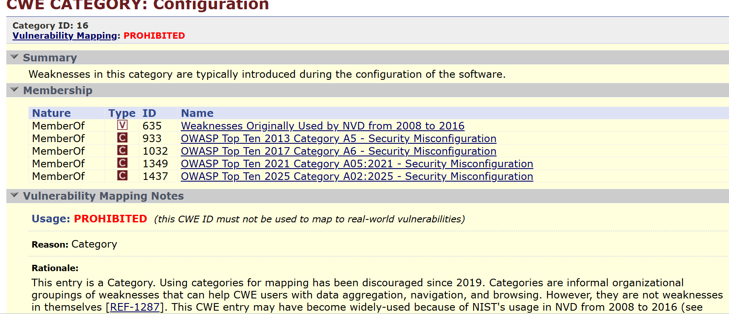

3.
Vulnerability Name:- Unimplemented or Unsupported Feature in UI
CWE/CVE :-CWE-447
OWASP/SANS Category:-A03:2025 Software Supply Chain Failure
Description:-
Unimplemented or Unsupported Feature in UI is a software vulnerability that occurs when a user interface (UI) includes features, options, or controls that appear functional but are not actually implemented or supported by the underlying system. These incomplete features may mislead users into believing that certain operations are available or properly secured, when in reality they are either non-functional or partially implemented.
This issue often arises during the software development process when UI elements such as buttons, links, or configuration options are added to the interface but the corresponding backend functionality is not developed or properly integrated. As a result, users may interact with these elements expecting them to perform a task, but the system may ignore the request, return an error, or behave unpredictably.

Business Impact::-

1. Misleading Security Controls
If a UI shows security-related features (such as enabling encryption, logging, or multi-factor authentication) that are not actually implemented, users or administrators may believe the system is secure when it is not. This false sense of security can expose the organization to serious cyber risks.

2. Poor User Experience
Users rely on the interface to perform tasks efficiently. If a feature appears available but does not work properly, it can lead to:
- User frustration
- Confusion about system capabilities
- Reduced productivity
This may negatively affect how customers or employees perceive the application.
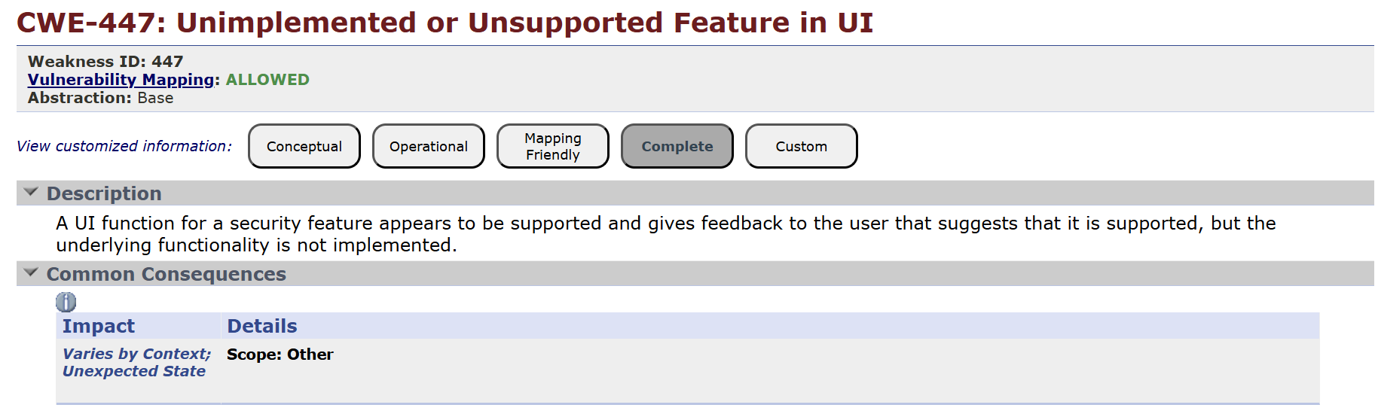

4.
Vulnerability Name:- Weak Encoding for Password
CWE/CVE :-CWE-261
OWASP/SANS Category:-A04:2025 Cryptographic Failures
Description:-
Weak Encoding for Password is a security vulnerability that occurs when passwords are stored or transmitted using weak or reversible encoding methods instead of strong cryptographic protection. Encoding techniques are primarily designed to convert data into another format for transmission or storage, but they do not provide real security. If passwords are encoded using weak methods, attackers may easily decode them and gain unauthorized access to user accounts.
In secure systems, passwords should never be stored in plain text or using simple encoding mechanisms. Instead, they should be protected using strong cryptographic hashing algorithms that make it extremely difficult to recover the original password. When weak encoding methods are used, attackers who gain access to the system database can easily retrieve and decode the stored passwords.
This vulnerability is documented in the **Common Weakness Enumeration as **CWE-261 (Weak Encoding for Password).

How Weak Password Encoding Occurs
Weak encoding for passwords typically occurs due to poor security practices during application development. Some common causes include:
- Using simple encoding methods such as Base64 instead of encryption or hashing.
- Storing passwords in plain text within databases or configuration files.
- Using outdated hashing algorithms that are easily cracked.
- Failing to use salt values when hashing passwords.
Encoding methods like Base64 can be reversed easily, meaning anyone who gains access to the encoded password can quickly decode it back into the original password.

Business Impact::-

1. Unauthorized Access to Systems
If passwords are weakly encoded, attackers who obtain the stored password data can easily decode it and gain access to user accounts. This may allow attackers to access sensitive systems such as:
- Customer accounts
- Internal company systems
- Administrative dashboards
- Financial platforms
Unauthorized access can lead to further attacks and data manipulation.

2. Data Breaches
Weak password encoding can expose sensitive information stored in company databases. If attackers successfully decode user passwords, they may access confidential data such as:
- Personal customer information
- Payment details
- Business records
- Proprietary data
Data breaches can have severe consequences for both customers and the organization.
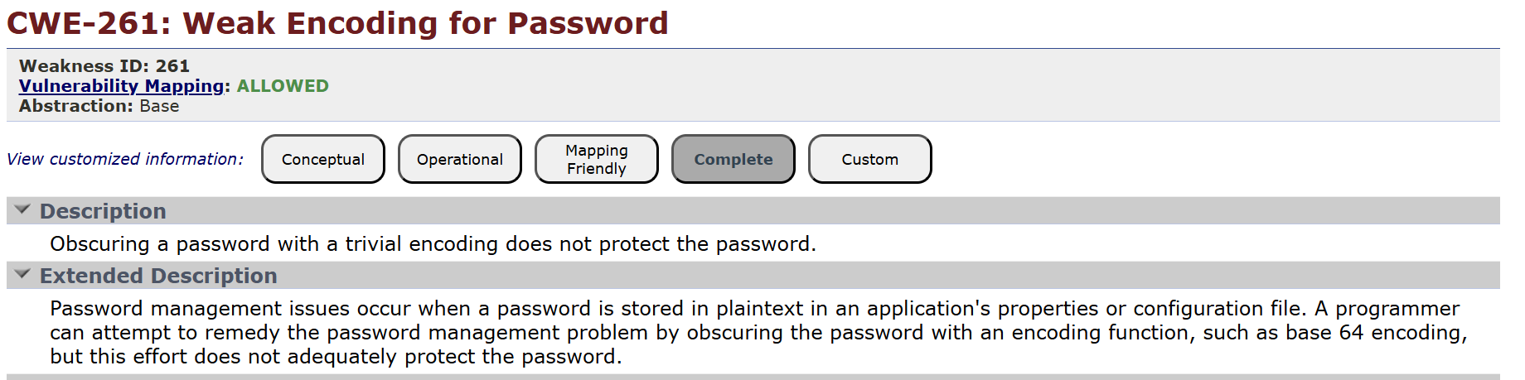

5.
Vulnerability Name:- Improper Input Validation
CWE/CVE :-CWE-20
OWASP/SANS Category:-A05:2025 Injection
Description:-
Improper Input Validation is a security vulnerability that occurs when a software application does not properly verify or sanitize the data provided by users or external sources before processing it. Input validation is a crucial step in secure software development because applications often receive data from various sources such as user forms, APIs, files, and network requests. If this data is not carefully checked, attackers may inject malicious input that can manipulate the system or compromise security.
This vulnerability is categorized in the **Common Weakness Enumeration as **CWE-20. Improper input validation is also closely related to several common web security issues highlighted by **OWASP in its security guidelines.
Improper input validation occurs when an application fails to check whether the input data is in the correct format, type, length, or range before using it in operations such as database queries, file processing, or command execution. When this happens, attackers can supply unexpected or malicious data that may cause the program to behave incorrectly.
For example, if a web application expects a numeric value for a user ID but does not verify the input, an attacker might provide a string containing malicious commands instead of a number. This could lead to serious vulnerabilities such as SQL injection, command injection, or cross-site scripting (XSS) attacks.

Business Impact::-

1. Data Breaches and Information Exposure
Improper input validation can allow attackers to perform attacks such as SQL injection, command injection, or cross-site scripting. These attacks may allow unauthorized access to sensitive data such as:
- Customer personal information
- Financial data
- Business records
- Login credentials
Exposure of such information can lead to major data breaches.

2. Financial Loss
Security incidents caused by improper input validation can result in significant financial costs, including:
- Expenses for investigating and fixing security issues
- System recovery and security upgrades
- Legal penalties and regulatory fines
- Compensation to affected customers
Organizations may also lose revenue if services are disrupted during the recovery process.
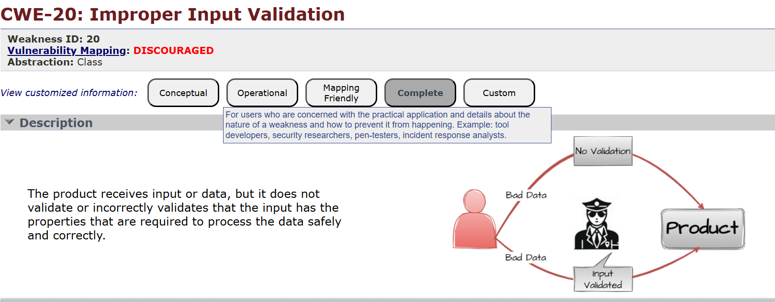

6.
Vulnerability Name:- Permissive List of Allowed Inputs
CWE/CVE :-CWE-183
OWASP/SANS Category:-A06:2025 Insecure Design
Description:-
Permissive List of Allowed Inputs is a security vulnerability that occurs when an application allows too many or overly broad input values without proper restrictions or validation. Instead of strictly defining what inputs are acceptable, the system permits a wide range of values, which may include malicious or unexpected data. This can create opportunities for attackers to exploit the application.
In secure software development, applications should validate user inputs carefully by allowing only specific, trusted values. However, when the list of allowed inputs is too permissive, the validation mechanism becomes weak and ineffective. As a result, attackers may inject harmful data into the system, potentially leading to security issues such as code injection, unauthorized access, or system malfunction.
This vulnerability is related to input validation weaknesses described in the **Common Weakness Enumeration database, particularly **CWE-183 (Permissive List of Allowed Inputs).

Business Impact::-

1. Increased Risk of Security Attacks
A permissive input validation system may allow attackers to inject malicious data into the application. This can lead to various attacks such as:
- SQL injection
- Command injection
- Cross-site scripting (XSS)
- Malicious file uploads
These attacks may compromise the security of the system and expose sensitive information.

2. Exposure of Sensitive Business Data
If attackers exploit weak input validation, they may gain unauthorized access to sensitive data stored in the system, such as:
- Customer personal information
- Financial records
- Business documents
- Login credentials
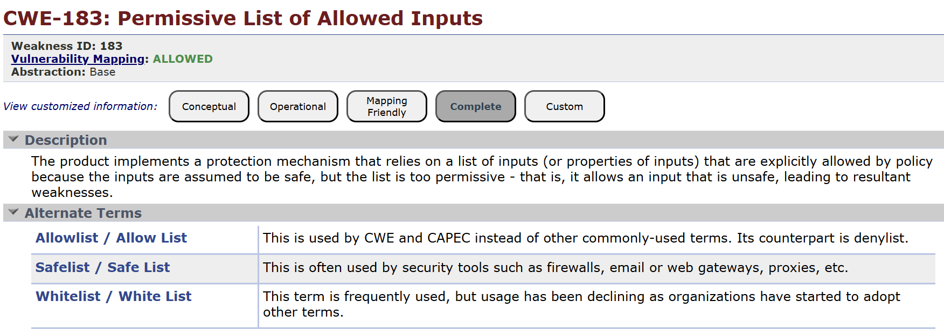

7.
Vulnerability Name:- Improper Authentication
CWE/CVE :-CWE-287
OWASP/SANS Category:-A07:2025 Authentication Failures
Description:-
Improper Authentication is a security vulnerability that occurs when a system fails to correctly verify the identity of a user, device, or process before granting access to resources or functionality. Authentication is a critical security mechanism used to ensure that only authorized users can access protected systems, applications, or data. When authentication is implemented incorrectly or incompletely, unauthorized users may gain access to sensitive information or system functions.
This vulnerability is commonly associated with weak authentication mechanisms such as missing authentication checks, weak password validation, improper session handling, or flawed login processes. As a result, attackers may bypass authentication controls and access restricted areas of an application without valid credentials.

Business Impact::-

1. Financial Loss
- Attackers may access financial systems or payment information.
- Fraudulent transactions or theft of funds can occur.
- Businesses may also face recovery and investigation costs.

2. Data Breaches
- Unauthorized users can access sensitive data such as customer details, trade secrets, or internal documents.
- This can lead to large-scale data leaks.

3. Reputation Damage
- Customers lose trust if their accounts or data are compromised.
- Negative publicity can reduce customer loyalty and future sales.

4. Legal and Regulatory Penalties
- Companies may face fines if they fail to protect user data.
- Regulations like General Data Protection Regulation (GDPR) or California Consumer Privacy Act (CCPA) require strong data protection.
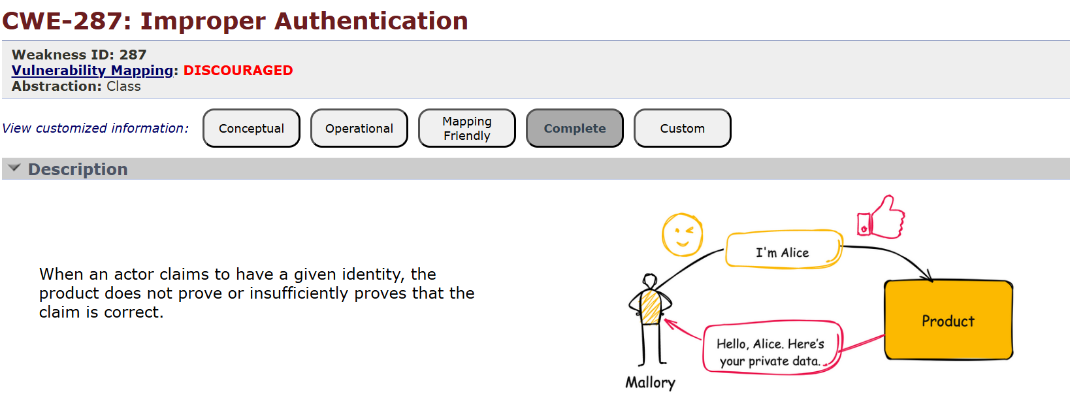

8.
Vulnerability Name:- Untrusted Search Path
CWE/CVE :-CWE-426
OWASP/SANS Category:-A08:2025 Software or Data Integrity Failures
Description:-
Untrusted Search Path is a software security vulnerability that occurs when a program searches for executable files or libraries in directories that may contain malicious or untrusted files. If an attacker places a malicious file in one of these directories, the application might unintentionally execute that file instead of the legitimate one. This can allow attackers to run unauthorized code within the system.
This vulnerability commonly occurs in operating systems such as Microsoft Windows and Linux, where applications search multiple directories to locate executable programs or dynamic libraries. The system follows a search path order, checking directories one by one until it finds the required file. If a malicious file is found earlier in the search path, it may be executed instead of the intended program.
For example, suppose an application needs to execute a system utility but does not specify the full path to the executable. The operating system will search through directories such as the current working directory, system directories, and other paths defined in environment variables. If an attacker places a malicious executable with the same name in a directory that is searched earlier, the program may execute the malicious file.

Business Impact::-

1. Unauthorized Execution of Malicious Code
If attackers exploit an untrusted search path vulnerability, they may place malicious executables or libraries in directories that the system checks first. When the application runs, it may execute the malicious file instead of the intended program. This can allow attackers to gain control over the system and perform unauthorized actions.

2. Data Breaches and Information Theft
Once attackers successfully execute malicious code through this vulnerability, they may access sensitive information stored in the system, such as:
- Customer data
- Financial records
- Internal business documents
- System credentials
Exposure of sensitive data can lead to serious security incidents and loss of confidential information.
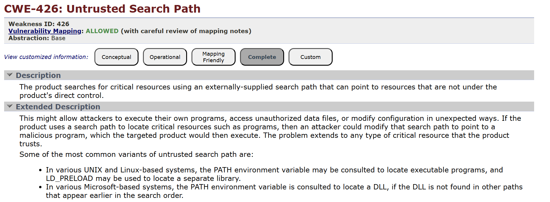

9.
Vulnerability Name:- Information Loss or Omission
CWE/CVE :-CWE-221
OWASP/SANS Category:-A09:2025 Security Logging & Alerting Failures
Description:-
Information Loss or Omission is a type of software vulnerability that occurs when a system fails to provide important information or loses critical data during processing, storage, or transmission. This issue can affect the reliability, security, and usability of an application because users or systems may not receive the necessary information required for proper decision-making or system operation.
In many software systems, applications are responsible for collecting, processing, and delivering information accurately. When some information is missing, incorrectly removed, or not transmitted, it may lead to incorrect results, incomplete records, or system errors. Information loss or omission can happen due to programming errors, improper data handling, insufficient validation, or system failures.
One of the major concerns with this vulnerability is that it can hide important events or security-related data, making it difficult for administrators to detect problems or security incidents. For example, if a logging system fails to record certain user activities or system errors, administrators may not be able to track suspicious behavior or diagnose issues effectively.
Information loss or omission can occur in several situations, including data transmission failures, incomplete data storage, incorrect database queries, or poor error handling in applications. For instance, when a program processes user input but fails to store some of the required fields in the database, the stored record becomes incomplete. Similarly, if a system transmits only partial data to another service due to a communication error, important information may be omitted.

Business Impact::-

1. Incorrect Business Decisions
Organizations rely on accurate data to make important business decisions. If information is lost or omitted from reports, databases, or system logs, management may make decisions based on incomplete or incorrect information. This can lead to poor planning, incorrect financial analysis, and ineffective strategies.

2. Data Integrity Issues
Information loss reduces the reliability and integrity of stored data. When data is incomplete or inconsistent, systems may produce inaccurate outputs or reports. This can affect business processes that depend on accurate records, such as financial management, inventory tracking, or customer service.
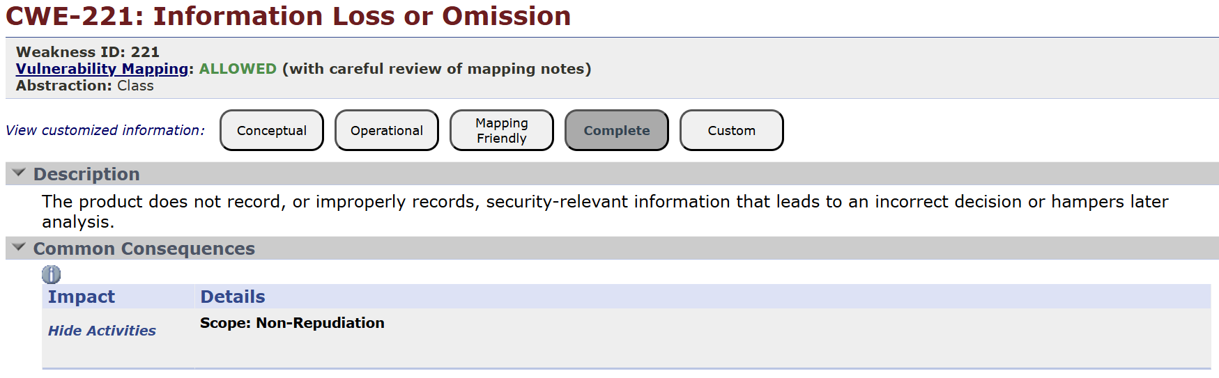

10.
Vulnerability Name:- NULL Pointer Dereference
CWE/CVE :-CWE-476
OWASP/SANS Category:-A10:2025 Mishandling of Exceptional Conditions
Description:-
A Null Pointer Dereference is a common software vulnerability that occurs when a program attempts to access or modify memory using a pointer that has a NULL value. In programming languages such as C and C++, a pointer is a variable that stores the memory address of another variable. When a pointer is assigned a NULL value, it means that the pointer does not refer to any valid memory location.
If a program tries to dereference (access the value at the memory location of) a NULL pointer, it results in a runtime error because the program attempts to access memory that does not exist or is not allocated. This typically leads to program crashes, unexpected behavior, or security vulnerabilities.

How NULL Pointer Dereference Occurs
A NULL pointer dereference occurs when:
- A pointer variable is declared but not initialized properly.
- The pointer is explicitly assigned NULL but later used without validation.
- Memory allocation fails and the program does not check if the allocation returned NULL.
- Objects or resources are freed and later accessed again.
When the program tries to read or write data through this invalid pointer, the operating system usually terminates the program to prevent memory corruption.

Business Impact::-

1. Application Crashes and Service Downtime
One of the most common consequences of a NULL pointer dereference is application failure or system crash. When the program attempts to access a null memory location, the operating system may terminate the process to protect system stability.
This can lead to:
- Service interruptions
- System downtime
- Reduced availability of business applications
For organizations that rely on online services, downtime can directly impact business operations.

2. Loss of Productivity
When systems crash frequently due to programming errors like NULL pointer dereference, employees may not be able to complete their tasks efficiently. This can slow down business processes and reduce overall productivity.
IT teams may also spend additional time diagnosing and fixing such issues instead of focusing on other important tasks.

